TASK 1
#include<stdio.h>
int main()
{
int marks_percentage,family_income;
family_income < 50000;
printf("enter your marks_percentage and family_income: ");
scanf("%d %d",&marks_percentage,&family_income);
if(marks_percentage >= 80 || family_income < 50000 )
{
printf("qualify scholarship");
}
else
{
printf("not qualify scholarship");
}
return 0;
}
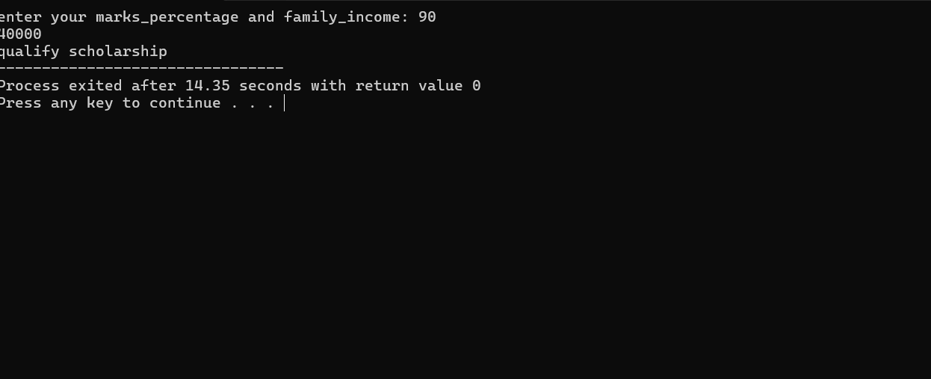

Task 2
#include<stdio.h>
int main()
{
int late_days;
printf("enter late_days: ");
scanf("%d",&late_days);
if(late_days ==0)
{
printf("no fine");
}
else if(late_days >1 && late_days <=5)
{
printf("fine Rs:50");
}
else if(late_days >6 && late_days <=10)
{
printf("fine Rs:100");
}
else if(late_days >10)
{
printf("fine Rs:200");
}

}

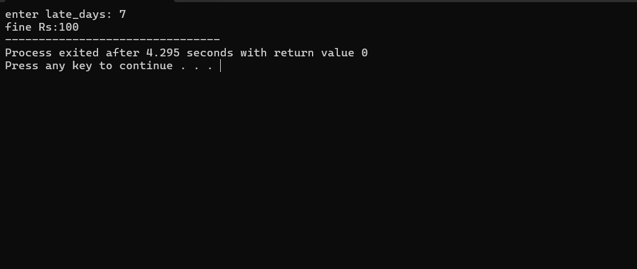

TASK 4
#include<stdio.h>
int main()
{
int length,width,area_of_rectangle,perimeter_of_rectangle;
printf("enter length and width: ");
scanf("%d %d",&length,&width);
area_of_rectangle = length*width;
perimeter_of_rectangle = 2*(length+width);
printf("%d\n",area_of_rectangle);
printf("%d\n",perimeter_of_rectangle);
}
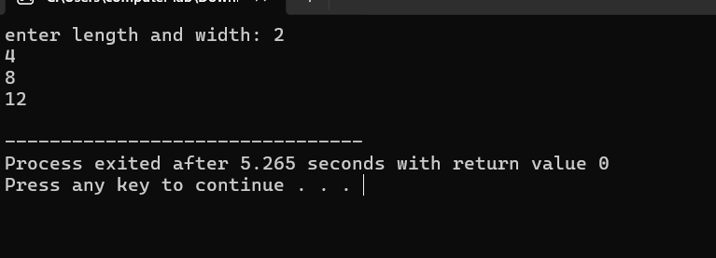

TASK 5
#include<stdio.h>
int main()
{
int integer,square,cube;
printf("enter integer,square,cube: ");
scanf("%d\n",&integer);
square = integer*integer;
cube = integer*integer*integer;
printf("%d\n",square);
printf("%d\n",cube);

}
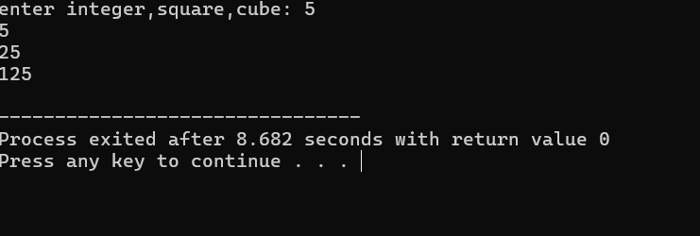

TASK 5
#include<stdio.h>
int main()
{
float celsius,fahrenheit;
printf("enter celsius: ");
scanf("%f",&celsius);
fahrenheit = (celsius*9/5)+32;
printf("%.2f",fahrenheit);

}
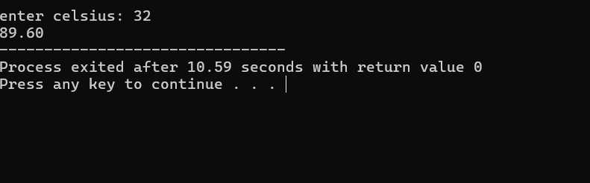

TASK 6
#include<stdio.h>
int main()
{
int num1,num2,num3;
float average;
printf("enter your numbers: ");
scanf("%d %d %d",&num1,&num2,&num3);
average = (num1+num2+num3)/3;
printf("%.3f",average);

}
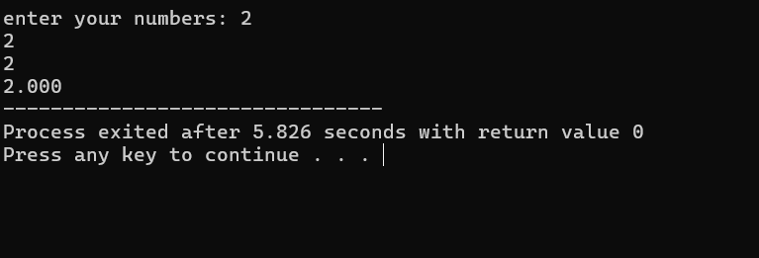

TASK 7
#include<stdio.h>
int main()
{
int marks;
marks=40;
if(marks >= 50)
{
printf("pass");
}
else
{
printf("fail");
}
}
